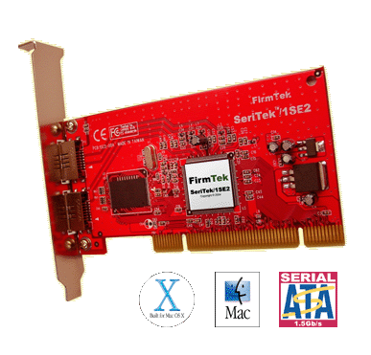


FOR IMMEDIATE RELEASE

FirmTek Launches First External Serial ATA Adapter for the Macintosh

New SeriTek/1SE2 SATA Host Adapter Offers Exclusive Hot-Swap Capabilities

UNION CITY, California – September 14, 2004 – FirmTek, LLC, a pioneer of Serial ATA (SATA) storage solutions for the Macintosh platform, today unveiled their new external SeriTek/1SE2 Serial ATA PCI host adapter. The SeriTek/1SE2 extends Serial ATA’s 1.5Gbits/sec performance to the outside of the Macintosh computer chassis, enabling users to take advantage of external Serial ATA enclosures. With two external ports, it provides the high bandwidth necessary to meet the needs of performance-hungry applications while offering hot-swap flexibility similar to that of Universal Serial Bus (USB) and FireWire.
“As their storage needs continue to grow, Macintosh users were given a choice for cost-effective high-performance storage when we introduced the popular SeriTek/1S2 internal PCI to SATA controller last year,” said Chi Kim Stanford, Vice President of Business Development for FirmTek. “We’re raising the bar by offering this external version which permits virtually unlimited storage possibilities. With SeriTek/1SE2,” continued Stanford, “users can add storage as needed and transport large amounts of data while maintaining Serial ATA performance and reliability. This is accomplished by allowing users to swap their hard disks on-the-fly without the burden of powering down their system. With external Serial ATA, users can expand their systems without having to replace internal drives. This is especially useful for G5 users who are limited to two internal drive bays.”
SeriTek/1SE2 Key Features and Benefits:
- Two external ports with patent-pending hot-swap capability: Hot-swaps both individual disks and disks within a RAID volume with OS 9 and OS X
- Ease of use “Plug and Play” functionality with zero driver installation overhead
- Boosts overall system performance with data transfer rates of up to 150MBytes/sec or 1.5Gbits/sec per port
- Compatible with all PCI-based Power PC Macintosh computers
- Supports Mac OS 8, 9, and OS X version 10.1.5 or later
- Provides performance and protection: Supports native OS X RAID 0/1; OS 9 RAID (with third party software)
- User-upgradeable firmware
- Large LBA support for drives larger than 137GB
- Includes a one-meter, fully shielded, thin and flexible SATA cable with 7-pin connector
- Minimizes system heat generation and power consumption
- Ideal for multimedia-intensive applications: audio/video capture and editing, and graphics manipulation/publishing
- Perfect for upgrading and expanding legacy and G5 Macintosh computers

Pricing and Availability
FirmTek’s SeriTek/1SE2 Serial ATA host adapter for the Macintosh will be available during the 4th quarter of 2004, with estimated retail pricing of USD$99.95. For more information about SeriTek/1SE2, please visit FirmTek’s website at www.firmtek.com.

About FirmTek
Headquartered in Silicon Valley and founded by former Apple engineers, FirmTek is a leading hardware and firmware research and development company focusing on Macintosh storage technologies. The company takes pride in developing the most reliable and most compatible high performance enhancement solutions offered through FirmTek’s OEM and worldwide distribution channels. For information on how FirmTek helps users deploy, and organizations develop advanced interface solutions, visit FirmTek's website at www.firmtek.com, or email info@firmtek.com.

Contact Information
Chi Kim Stanford
FirmTek, LLC
cks@firmtek.com
Tel: 510-487-0927
Fax: 510-315-3077
www.firmtek.com

SeriTek, UltraTek, AV-Tek, and FirmTek are trademarks of FirmTek, LLC. Macintosh, “Mac OS 9” and “OS X” are trademarks of Apple Computer, Inc. Some peripherals, such as CD and DVD burners, may require third party authoring software to utilize their complete set of features.

# # #

